**CHAPTER 1**

**INTRODUCTION**

**1.1 Introduction:**

Energy storage is a critical and growing need in the drive to increase the efﬁciency and effectiveness of power systems. In the quest for higher fuel efﬁciency, energy storage is becoming increasingly important in ground transportation. Renewable energy sources such as wind and solar require energy storage to buffer power production deﬁcits. Home energy storage can reduce costs by taking grid power during low-demand periods (e.g., at night) and reducing grid power during high-demand periods. There are many ways to store energy (e.g., ﬂywheels, ultra-capacitors, and compressed air) but batteries are the best choice for most applications. Batteries can be scaled from small (cell phone), to medium (HEVs), to large (grid) applications. They are highly efﬁcient and have high energy-to-weight ratios. There are safe and recyclable designs. Cost and battery life, however, are concerns that prevent more widespread application of batteries for energy storage applications. Researchers are continually inventing lower cost and longer life battery chemistries.

Nowadays, Lithium-ion batteries are used in various applications, ranging from personal electronic devices, like cell phones, to the emerging class of electric vehicles. Because of the fragile nature of this types of batteries, when compared to lead-acid or NiCd (Nickel-Cadmium) batteries, a comparatively advanced monitoring is necessary for safe operation.

The complexity of Battery Management Systems (BMS) strongly depends on the individual application. In simple case, like single cell batteries in mobile phones, or e-book readers, a simple “fuel gauge” Integrated Circuit (IC) like e.g., Texas Instruments bq27220 Single-Cell CEDV Fuel Gauge or Maxim Integrated MAX17048/MAX17049 Micropower 1-cell/2-cell Li+ModelGauge ICs can be sufficient. This ICs usually are able to measure voltage, temperature and current and use simple method to estimate the batteries current State of Charge (SOC). In more complex devices, like electric cars, the BMS has to fulfil more sophisticated tasks. In addition the basic parameter like cell voltage, cell current and cell temperature have to be measured. Nevertheless advance algorithms are needed as e.g., the available energy as to determine in order the reliable calculate the cruising range.

The general structure of Battery Management System (BMS) is shown in fig. 1. The BMS generally controlling the charge and discharge currents going into and out of the

*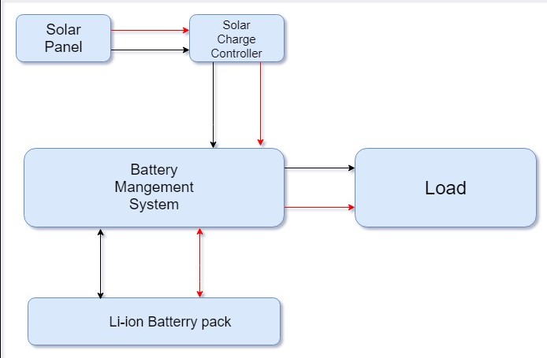Fig.1.1*

Battery pack, limiting overcharge and undercharge in the cells, balancing the cells and maintaining safe operation of the pack. But the general Battery Management System (BMS) has a drawback that it does not give a real-time data of different parameters such as rate of drain current, charging current, cell voltage, cell temperature and charging and drain duration.

This project focuses on the hardware aspects of Battery Management System for Lithium-Ion batteries and digitizing the